**PROJECT REPORT**

A NOVEL METHOD FOR HANDWRITTEN DIGIT RECOGNITION SYSTEM

**TEAM MEMBERS**

**- SHEIKH AMEENUL HAJI**

**- RITHISH A**

**- SRIKANTH**

**- ARAVIND J**

**Project Report Format**

1. **INTRODUCTION** 
   1. Project Overview

A Novel Method for Handwritten Digit Recognition System

Domain- Artificial Intelligence

Handwriting recognition is one of the compelling research works going on because every individual in this world has their own style of writing. It is the capability of the computer to identify and understand handwritten digits or characters automatically. Because of the progress in the field of science and technology, everything is being digitalized to reduce human effort. Hence, there comes a need for handwritten digit recognition in many real-time applications. MNIST data set is widely used for this recognition process and it has 70000 handwritten digits. We use Artificial neural networks to train these images and build a deep learning model. Web application is created where the user can upload an image of a handwritten digit. this image is analyzed by the model and the detected result is returned on to UI.

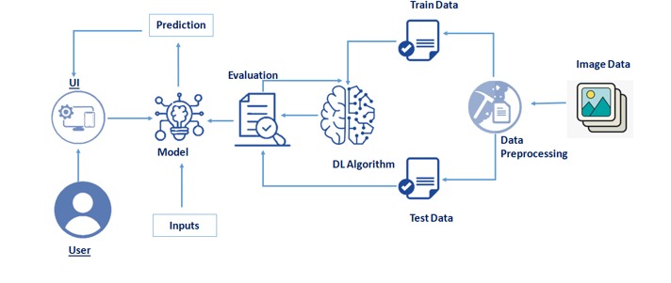

* 1. Purpose
* The purpose of this project is to:
* The user interacts with the UI (User Interface) to upload the image as input
* The uploaded image is analyzed by the model which is integrated
* Once the model analyses the uploaded image, the prediction is showcased on the UI

1. **LITERATURE SURVEY**
   1. Existing problem

As we know that today time is of great importance so we have try to manage time correctly. We can see that bank employee cannot manually enter the details in computer of a challan ,cheque, or withdrawal form if there is a long queue of people are waiting for getting their work done.Sorting letters according to their pincodes is also difficult task which takes a long time.Hence to resolve all this problem that we face in work life ,we can use software for handwritten recognition software which will greater the reduce the effect and time .

* 1. References
* [1] J. Li, G. Sun, L. Yi, Q. Cao, F. Liang and Y. Sun, "Handwritten Digit Recognition System Based on Convolutional Neural Network," 2020 IEEE International Conference on Advances in Electrical Engineering and Computer Applications( AEECA), 2020, pp. 739-742, doi: 10.1109/AEECA49918.2020.9213619.
* [2] A. Chakraborty, R. De, S. Malakar, F. Schwenker and R. Sarkar, "Handwritten Digit String Recognition using Deep Autoencoder based Segmentation and ResNet based Recognition Approach," 2020 25th International Conference on Pattern Recognition (ICPR), 2021, pp. 7737-7742, doi: 10.1109/ICPR48806.2021.9412198.
* [3] S. Aly and S. Almotairi, "Deep Convolutional Self-Organizing Map Network for Robust Handwritten Digit Recognition," in IEEE Access, vol. 8, pp. 107035-107045, 2020, doi: 10.1109/ACCESS.2020.3000829.
* [4] S. Aly and A. Mohamed, "Unknown-Length Handwritten Numeral String Recognition Using Cascade of PCA-SVMNet Classifiers," in IEEE Access, vol. 7, pp. 52024-52034, 2019, doi: 10.1109/ACCESS.2019.2911851.
* [5] A. K. Agrawal, A. K. Shrivas and V. k. Awasthi, "A Robust Model for Handwritten Digit Recognition using Machine and Deep Learning Technique," 2021 2nd International Conference for Emerging Technology (INCET), 2021, pp. 1-4, doi: 10.1109/INCET51464.2021.9456118.
* [6] W. Liu, J. Wei and Q. Meng, "Comparisions on KNN, SVM, BP and the CNN for Handwritten Digit Recognition," 2020 IEEE International Conference on Advances in Electrical Engineering and Computer Applications( AEECA), 2020, pp. 587-590, doi: 10.1109/AEECA49918.2020.9213482.
* [7] T. Pala, U. Güvenç, H. T. Kahraman, İ. Yücedağ and Y. Sönmez, "Comparison of Pooling Methods for Handwritten Digit Recognition Problem," 2018 International Conference on Artificial Intelligence and Data Processing (IDAP), 2018, pp. 1-5, doi: 10.1109/IDAP.2018.8620848.
* [8] S. Ahlawat and R. Rishi, "Handwritten Digit Recognition using Adaptive Neuro-Fuzzy System and Ranked Features," 2018 International Conference on Computing, Power and Communication Technologies (GUCON), 2018, pp. 1128-1132, doi: 10.1109/GUCON.2018.8675013.
  1. Problem Statement Definition

Handwriting recognition is one of the compelling research works going on because every individual in this world has their own style of writing. It is the capability of the computer to identify and understand handwritten digits or characters automatically. Recognition of Handwritten Digits using Convolutional neural networks .

1. **IDEATION & PROPOSED SOLUTION**
   1. Empathy Map Canvas

* An empathy map is a straightforward, simple-to-understand picture that summarizes information about a user's actions and views.
* Teams can utilize an empathy map as a collaborative tool to obtain a deeper understanding of their customer.
* An empathy map is a popular visualization tool in the UX and HCI fields of practice.
* An empathy map's main objective in empathetic design is to bridge the understanding of the end user.
* A rectangle divided into four quadrants, with the user or client in the center, is an empathy map. A category is included in each of the four quadrants to assist us better understand the user's perspective.
* The four empathy map quadrants examine the user's actions, thoughts, and feelings.

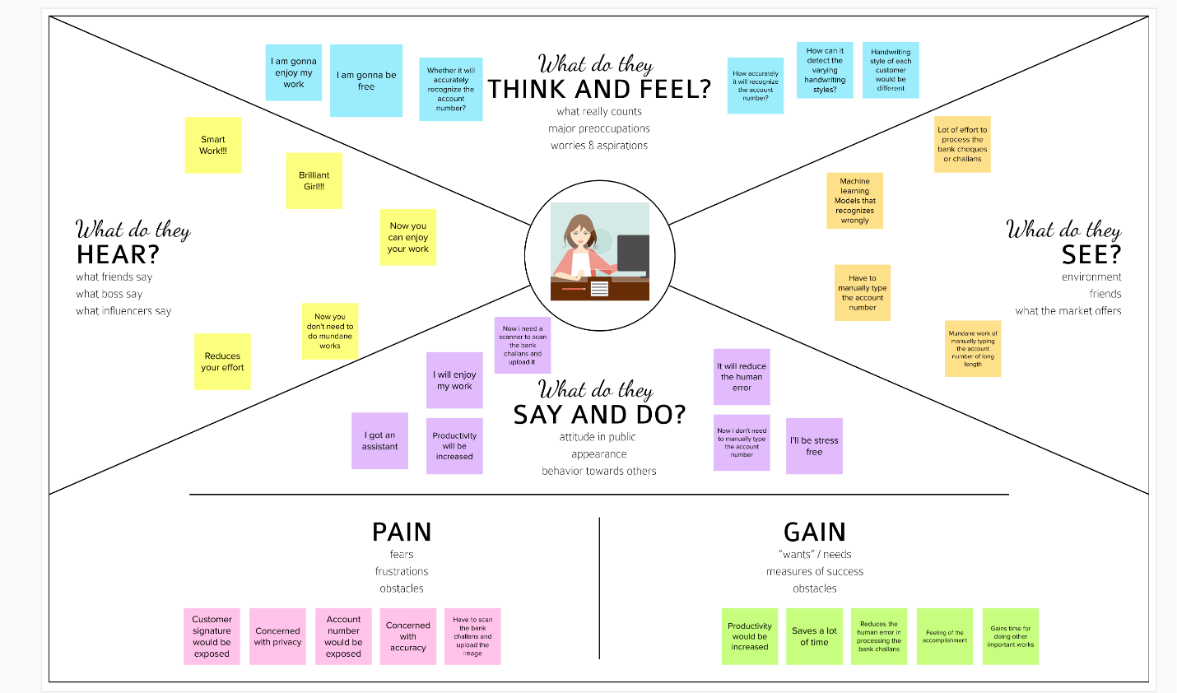

Figure 3.1 Empathy Map

* 1. Ideation & Brainstorming

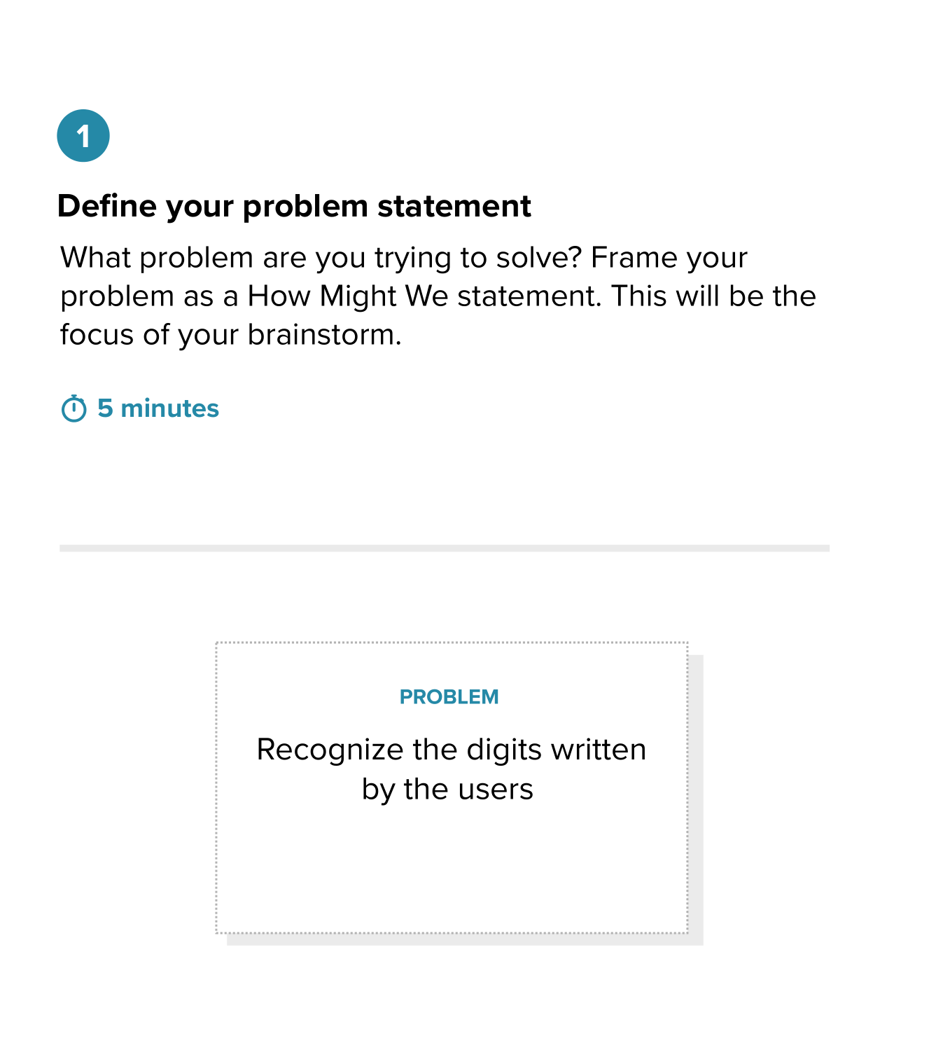

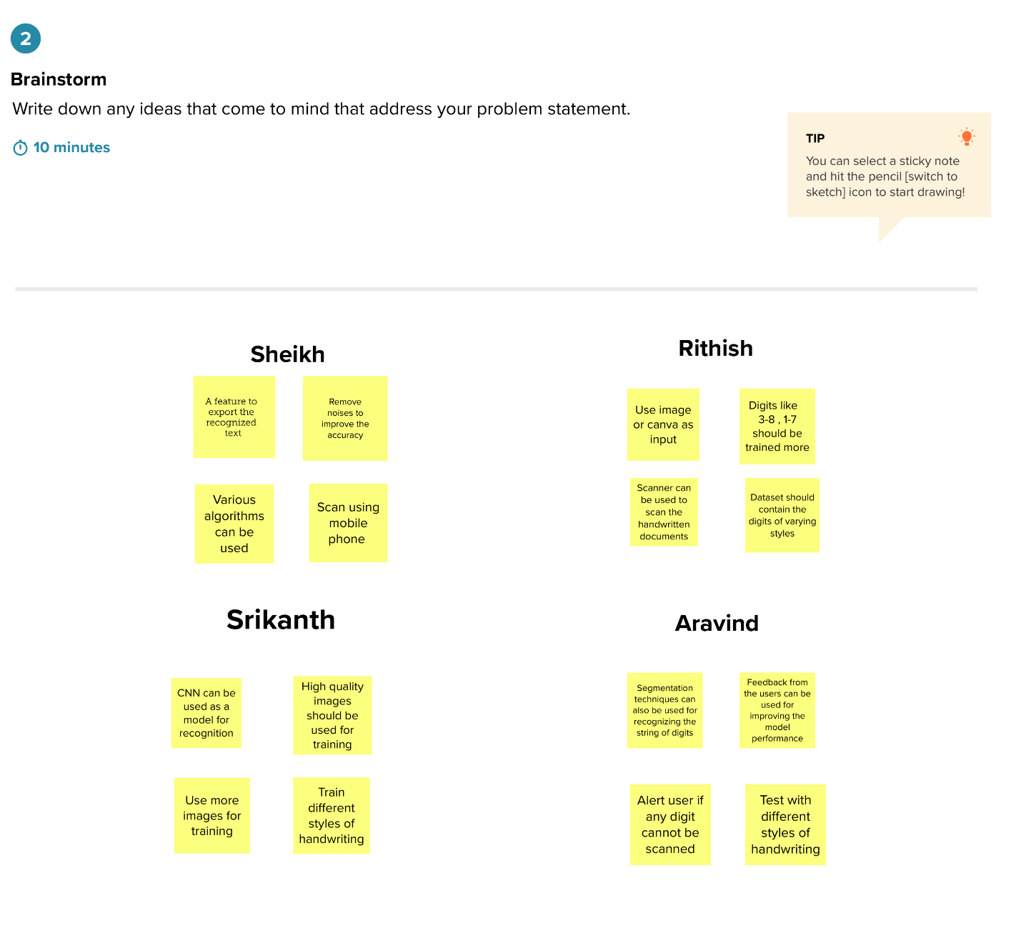

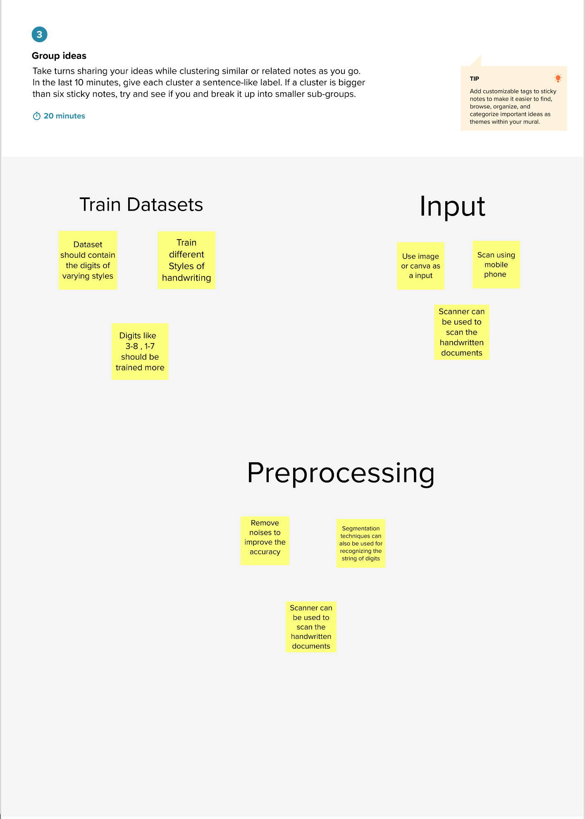

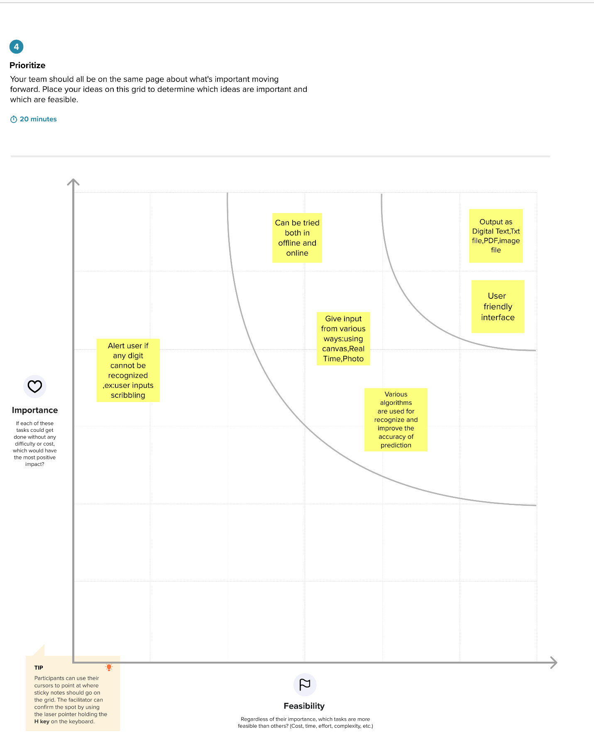

* 1. Proposed Solution

|  |  |  |
| --- | --- | --- |
| **S.No.** | **Parameter** | **Description** |
|  | Problem Statement (Problem to be solved) | Recognize handwritten expressions consisting of digits and mathematical symbols and evaluate the expression. |
|  | Idea / Solution description | Image dataset of digits and symbols are used to train the CNN model and it is used to find the digits or expression in digital form and it is processed |
|  | Novelty / Uniqueness | Rather than only recognizing the (0-9) digits our project can recognize the digits along with mathematical symbols (+,-,*,/,(,)) and calculate the value of the expression ("2 +3-6 ", “8*6-4”) |
|  | Social Impact / Customer Satisfaction | The project will be useful for customers like bank staffs, students, etc to recognize digits and also solve expression |
|  | Business Model (Revenue Model) | Revenue can be generated by making it as an web app by which anyone can access it. |
|  | Scalability of the Solution | In the future the model can be used to recognize complex mathematical expression which has some different symbols like root functions, sin ,cos, differential, integration, etc. It will be very helpful to recognize some notes which are tough to understand. |

* 1. Problem Solution fit

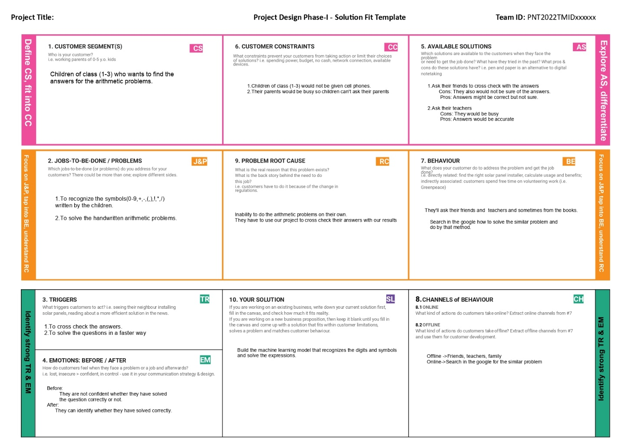

1. **REQUIREMENT ANALYSIS**
   1. Functional requirement

|  |  |  |
| --- | --- | --- |
| **FR No.** | **Functional Requirement (Epic)** | **Sub Requirement (Story / Sub-Task)** |
| FR-1 | Website | UI for the website |
| FR-2 | Upload option | The upload option used by the user to upload the iage to be recognized. |
| FR-3 | Result | The result will be displayed in the website in digital form. |

* 1. Non-Functional requirements

|  |  |  |
| --- | --- | --- |
| **FR No.** | **Non-Functional Requirement** | **Description** |
| NFR-1 | **Usability** | The website is easy to use. |
| NFR-2 | **Reliability** | Since more amount and variety of dataset is used, the output is reliable to an greater extent. |
| NFR-3 | **Performance** | Since CNN is used, the performance of the model will be fast. |
| NFR-4 | **Availability** | The project is hosted on a platform where it is always available. |

1. **PROJECT DESIGN**
   1. Data Flow Diagrams

Simplified: DFD-0(DATA FLOW DIAGRAM-0)

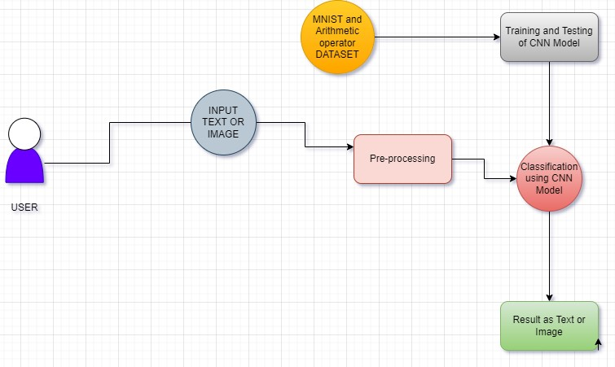

DFD-1(DATA FLOW DIAGRAM 1)

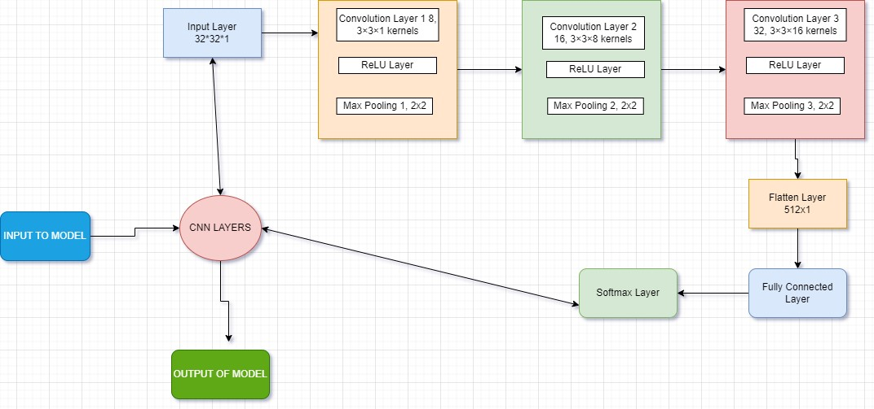

* 1. Solution & Technical Architecture

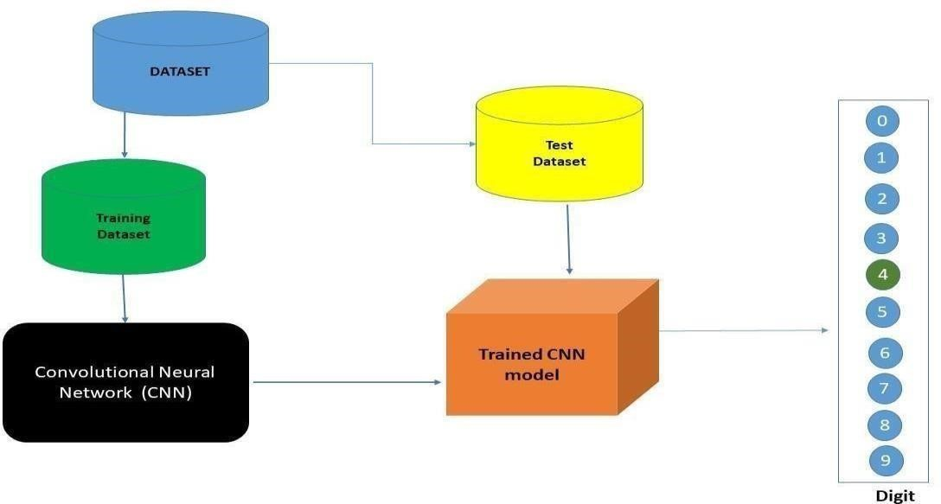

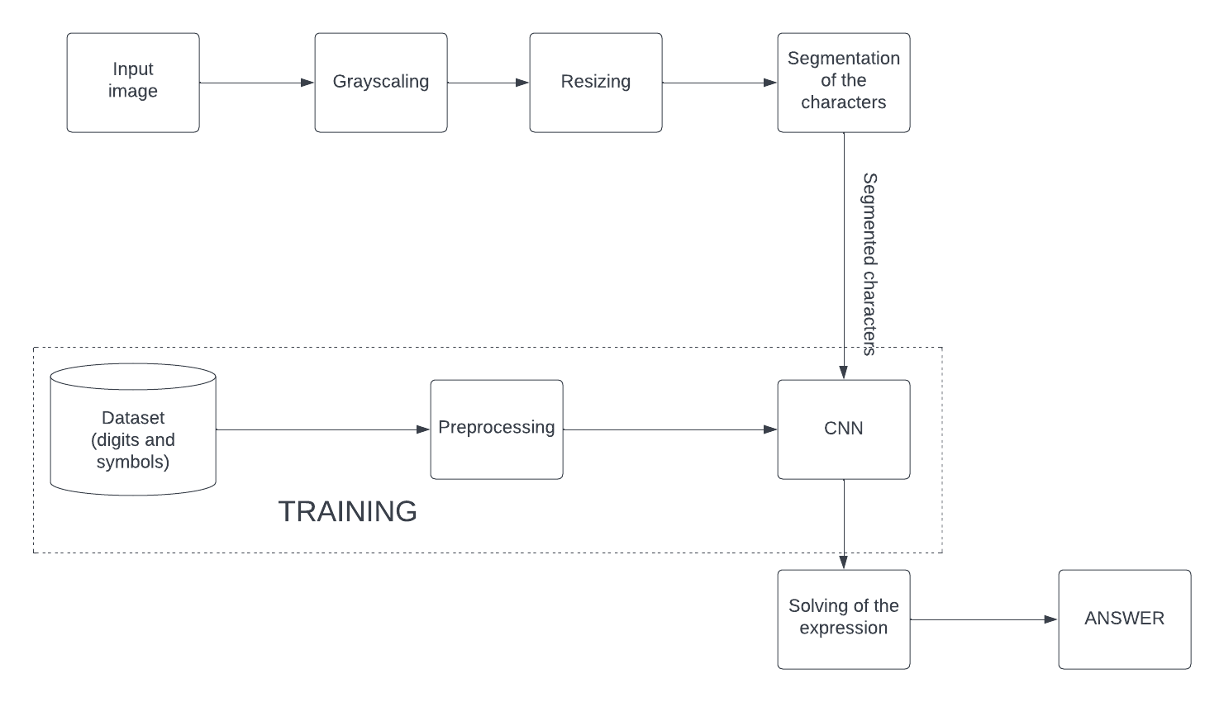

* 1. User Stories

|  |  |  |  |  |  |
| --- | --- | --- | --- | --- | --- |
| **User Type** | **User Story**  **Number** | **User Story / Task** | **Acceptance criteria** | **Priority** | **Release** |
| Customer | USN-1 | I can use this Web App to do calculation for basic math like addition, subtraction etc. | I am getting the result | Medium | Sprint-1 |
|  | USN-2 | I am a postman, I want to recognize the numbers in letters for delivery. | I can get the digital text to store it in computer memory | Medium | Sprint-1 |
|  | USN-3 | I am bank employee,I want to recognize digits of cheque or challan and enter in computer | I can get the numbers from the cheque | Medium | Sprint-2 |
|  | USN-4 | As a user, I can able to input the images of digital documents to the application | As a user, I can able to input the images of digital documents to the application | High | Sprint-2 |
|  | USN-5 | As a user I can able to get the recognised digit as output from the images of digital documents or images | I can access the recognized digits from digital document or images | High | Sprint-3 |
|  | USN-6 | As a user, I will train and test the input to get the maximum accuracy of output. | I can able to train and test the application until it gets maximum accuracy of the result. | Medium | Sprint-3 |
| Customer (Web  user) | USN-7 | As a user, I can use the web application virtually anywhere. | I can use the application in any device with a browser | Medium | Sprint-4 |

1. **PROJECT PLANNING & SCHEDULING**
   1. Sprint Planning & Estimation

| **Sprint** | **Functional Requirement (Epic)** | **User Story Number** | **User Story / Task** | **Story Points** | **Priority** | **Team Members** |
| --- | --- | --- | --- | --- | --- | --- |
| Sprint-1 | Data Collection | USN-1 | Collects the different handwritten digits along with the handwritten mathematical symbols(+,-,*,/) | 2 | High | Sheik Ameenul Haji,Aravind |
| Sprint-1 | Data Preprocessing | USN-2 | Preprocess the Collected data like scaling ,resizing the images etc | 1 | High | Rithish,Srikanth |
| Sprint-2 | Model Building | USN-3 | Build the CNN Model | 1 | Medium | Sheik,Aravind |
| Sprint-2 | Compiling Model | USN-4 | Compile the built model | 1 | Medium | Srikanth,Sheik |
| Sprint-2 | Train the model | USN-5 | Train the built model using the datasets | 1 | High | Rithish,Sheik |
| Sprint -2 | Save the model | USN-6 | Save the trained model weights | - | Medium | Aravind,Srikanth |
| Sprint-3 | Evaluate the user given arithmetic expression | USN-7 | User should give the handwritten arithmetic expression, the model should give the correct result | 1 | High | Rithish,Aravind |
| Sprint -4 | Build the web app | USN-8 | User should upload the image using web app and the answer should be displayed in the web app | 1 | Medium | Sheik,Srikanth |

* 1. Sprint Delivery Schedule

| **Sprint** | **Total Story Points** | **Duration** | **Sprint Start Date** | **Sprint End Date (Planned)** | **Story Points Completed (as on Planned End Date)** | **Sprint Release Date (Actual)** |
| --- | --- | --- | --- | --- | --- | --- |
| Sprint-1 | 20 | 6 Days | 24 Oct 2022 | 29 Oct 2022 | 1,2 | 30 Oct 2022 |
| Sprint-2 | 20 | 6 Days | 31 Oct 2022 | 05 Nov 2022 | 2,3 | 04 Nov 2022 |
| Sprint-3 | 20 | 6 Days | 07 Nov 2022 | 12 Nov 2022 | 1,2 | 11 Nov 2022 |
| Sprint-4 | 20 | 6 Days | 14 Nov 2022 | 19 Nov 2022 | 1,2 | 19 Nov 2022 |

1. **CODING & SOLUTIONING (Explain the features added in the project along with code)**

The user can upload the image for prediction choose from the from his local directory and the image is predicted and displayed in the front end.The trained model is saved in same directory and used for prediction as given.

7.1.Feature1

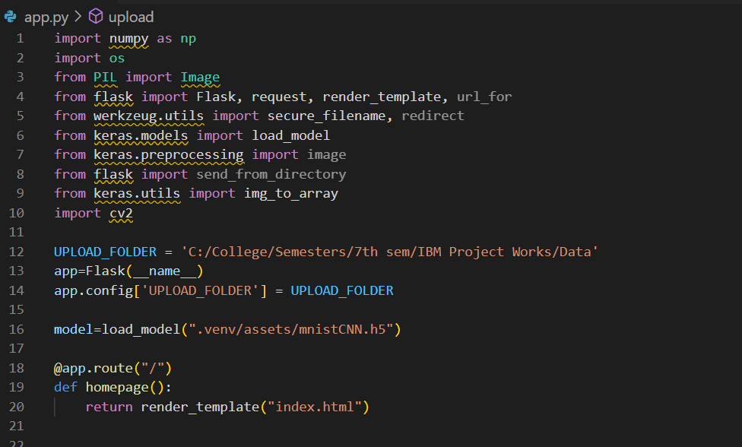

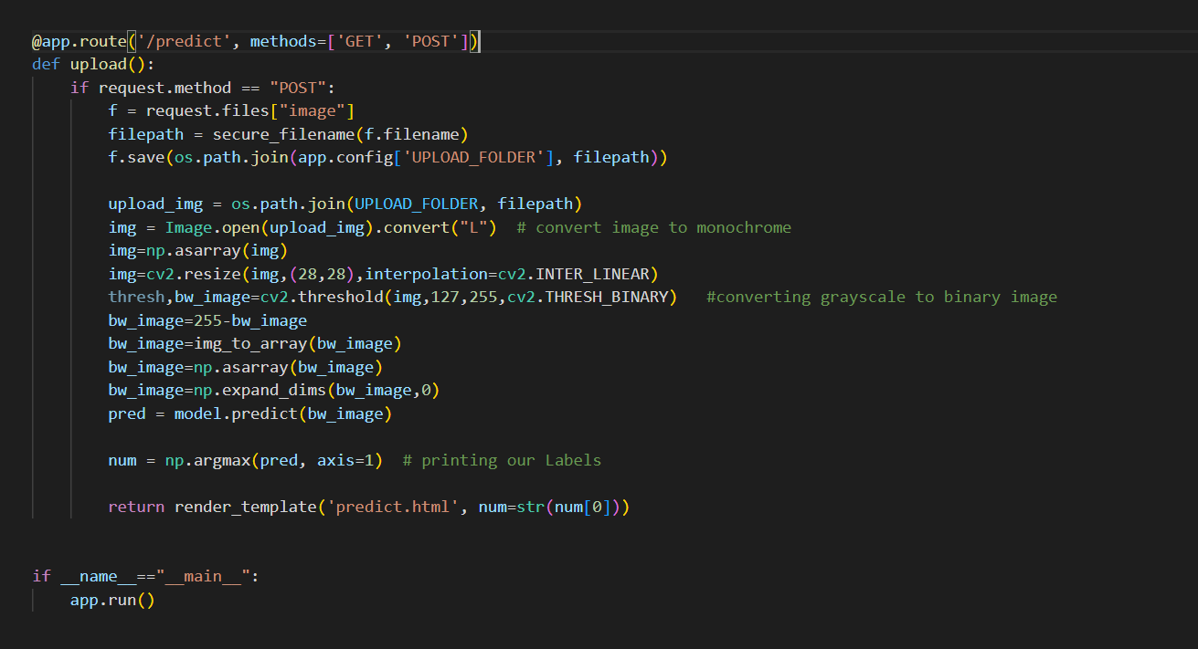

7.2.Feature 2

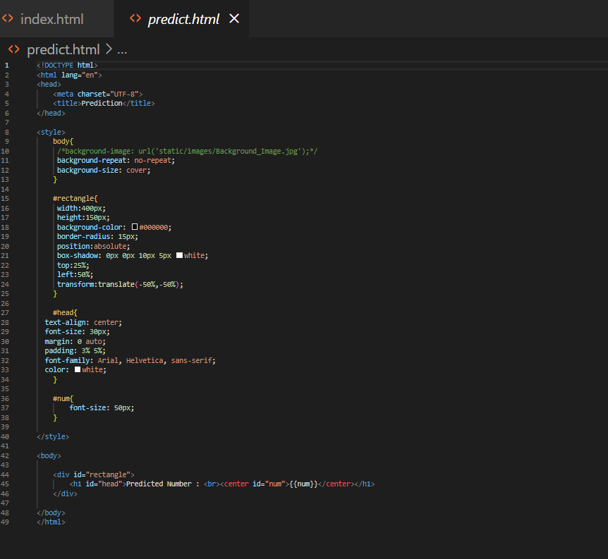

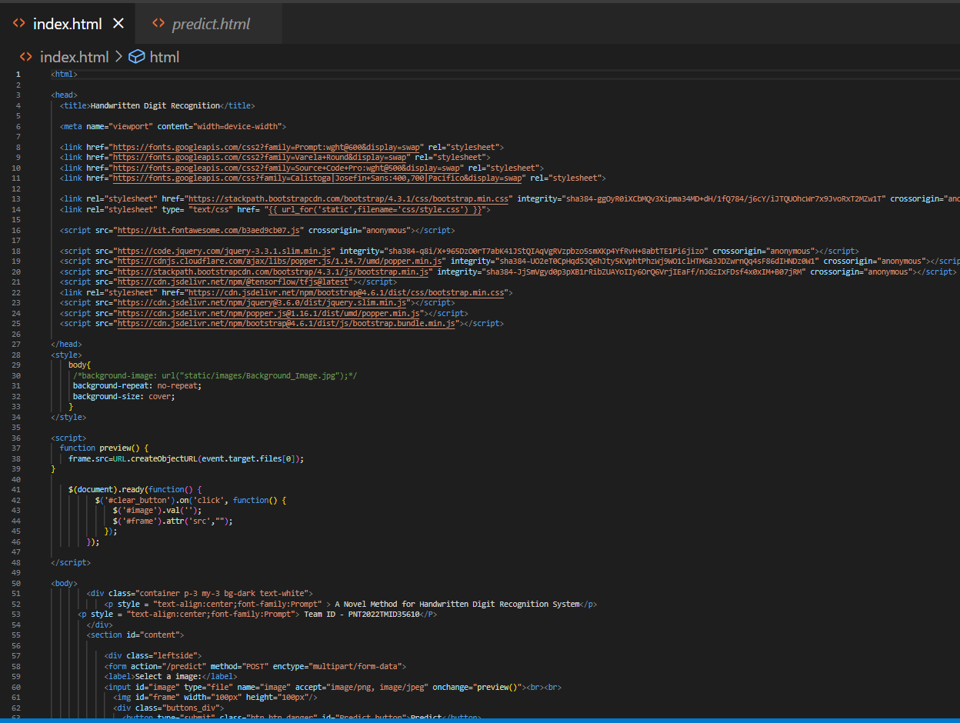

1. **TESTING** 
   1. Test Cases

|  |  |  |  |  |  |  |  |  |  |  |
| --- | --- | --- | --- | --- | --- | --- | --- | --- | --- | --- |
| **Test case ID** | **Feature Type** | **Component** | **Test Scenario** | **Steps To Execute** | **Test Data** | **Expected Result** | **Actual Result** | **Status** | **BUG ID** | **Executed By** |
| HP_TC_001 | UI | Home Page | Verify UI elements in the Home Page | 1. Open the page 2. Check if all the UI elements are displayed 3. Click on My Account dropdown button 4. Verify login/Sign up popup displayed or not | 127.0.0.5000 | The Home page must be displayed properly | Working as expected | Pass |  | Sheikh Ameenul Haji,Rithish A |
| HP_TC_002 | UI | Home Page | Check if the UI elements are displayed properly in different screen sizes | 1. Open the page in a specific device 2. Check if all the UI elements are displayed properly 3. Repeat the above steps with different device sizes | Screen sizes: 2560 x 1801, 1440 x 970, 1024 x 840, 768 x 630, 320 x 630 | The Home page must be displayed properly in all sizes | Working as expected | Pass |  | Aravind J,Srikanth |
| HP_TC_003 | Functional | Home page | Check if user can upload their file | 1. Open the page 2. Click on select button 3. Select the input imag | 1.png | The input image should be uploaded to the application successfully | Working as expected | Pass |  | Sheikh Ameenul Haji,Srikanth |
| HP_TC_004 | Functional | Home Page | Check if user cannot upload unsupported files | 1. Open the page 2. Click on select button 3. Select a random input file | installer.exe | The application should not allow user to  select a non image  file | User is able to upload any file | Fail | BUG_ID_001 | Aravind J,Rithish A |
| HP_TC_005 | Functional | Home Page | Check if the page redirects to the result page once the input is given | 1. Open the page 2. Click on select button 3. Select the input image 4. Check if the page redirects | 1.png | The page should redirect to the results page | Working as expected | Pass |  | Sheikh Ameenul Haji,Rithish A |
| BE_TC_001 | Functional | Backend | Check if all the routes are working properly | 1. Go to Home Page 2. Upload the input image 3. Check the reults page | 1.png | All the routes should properly work | Working as expected | Pass |  | Aravind J,Srikanth |
| M_TC_001 | Functional | Model | Check if the model can handle various image sizes | 1. Open the page in a specific device 2. Upload the input image 3)Repeat the above steps with different input image | 1.png, 2.png, 3.png | The model should rescale the image and predict the results | Working as expected | Pass |  | Sheikh Ameenul haji,Aravind J |
| M_TC_002 | Functional | Model | Check if the model predicts the digit | 1. Open the page 2. Click on select button 3. Select the input image 4. Check the results | 1.png | The model should predict the number | Working as expected | Pass |  | Srikanth,Rithish A |
| M_TC_003 | Functional | Model | Check if the model can handle complex input image | 1. Open the page 2. Click on select button 3. Select the input image 4. Check the results | 4.png | The model should predict the number in the complex image | Working as expected | Pass |  | Sheikh Ameenul Haji,Rithish A |
| RP_TC_001 | UI | Result Page | Verify UI elements in the Result Page | 1)Open the page 2)Click on select button 3)Select the input image  4)Check if all the UI elements are displayed properly | 1.png | The Result page must be displayed properly | Working as expected | Pass |  | Aravind J,Srikanth |
| RP_TC_002 | UI | Result Page | Check if the input image is displayed properly | 1)Open the page 2)Click on select button 3)Select the input image  4) Check if the input image are displayed | 1.png | The input image should be displayed properly | Working as expected | Pass |  | Sheikh Ameenul Haji,Srikanth |
| RP_TC_003 | UI | Result Page | Check if the result is displayed properly | 1. Open the page 2. Click on select button 3. Select the input image 4. Check if the result is displayed | 1.png | The result should be displayed properly | Working as expected | Pass |  | Aravind J,Srikanth |
| RP_TC_004 | UI | Result Page | Check if the other predictions are displayed properly | 1)Open the page 2)Click on select button 3)Select the input image  4)Check if all the other predictions are displayed | 1.png | The other predictions should be displayed properly | Working as expected | Pass |  | Sheikh Ameenul Haji,Rithish A |

* 1. User Acceptance Testing

User Acceptance Testing (UAT) is a type of testing performed by the end user or the client to verify/accept the software system before moving the software application to the production environment. UAT is done in the final phase of testing after functional, integration and system testing is done. The main Purpose of UAT is to validate end to end business flow. It does not focus on cosmetic errors, spelling mistakes or system testing. User Acceptance Testing is carried out in a separate testing environment with production-like data setup. It is a kind of black box testing where two or more end-users will be involved. Need of User Acceptance Testing arises once software has undergone Unit, Integration and System testing because developers might have built software based on requirements document by their own understanding and further required changes during development may not be effectively communicated to them, so for testing whether the final product is accepted by client/end-user, user acceptance testing is needed.

**Defect Analysis**

This report shows the number of resolved or closed bugs at each severity level, and how they were resolved

|  |  |  |  |  |  |
| --- | --- | --- | --- | --- | --- |
| **Resolution** | **Severity 1** | **Severity 2** | **Severity 3** | **Severity 4** | **Subtotal** |
| By design | 1 | 0 | 1 | 1 | 3 |
| Duplicate | 1 | 0 | 0 | 0 | 1 |
| External | 0 | 0 | 2 | 0 | 2 |
| Fixed | 4 | 1 | 0 | 1 | 6 |
| Not Reproduced | 0 | 0 | 1 | 1 | 2 |
| Skipped | 0 | 0 | 1 | 1 | 2 |
| Won’t Fix | 1 | 0 | 1 | 0 | 2 |
| Total | 7 | 1 | 6 | 4 | 18 |

**Test Case Analysis**

This report shows the number of test cases that have passed, failed, and untested

|  |  |  |  |  |
| --- | --- | --- | --- | --- |
| **Section** | **Total Cases** | **Not Tested** | **Fail** | **Pass** |
| Client Application | 10 | 0 | 3 | 7 |
| Security | 2 | 0 | 1 | 1 |
| Performance | 3 | 0 | 1 | 2 |
| Exception Reporting | 2 | 0 | 0 | 2 |

1. **RESULTS**
   1. Performance Metrics

**Model Summary**

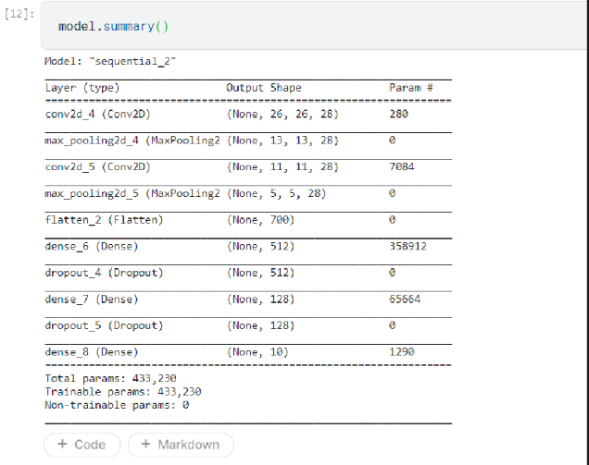

**Accuracy**

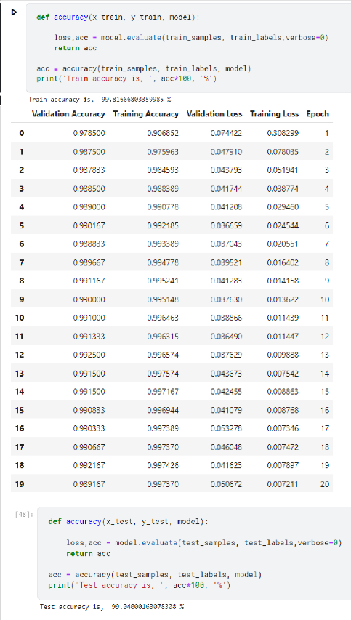

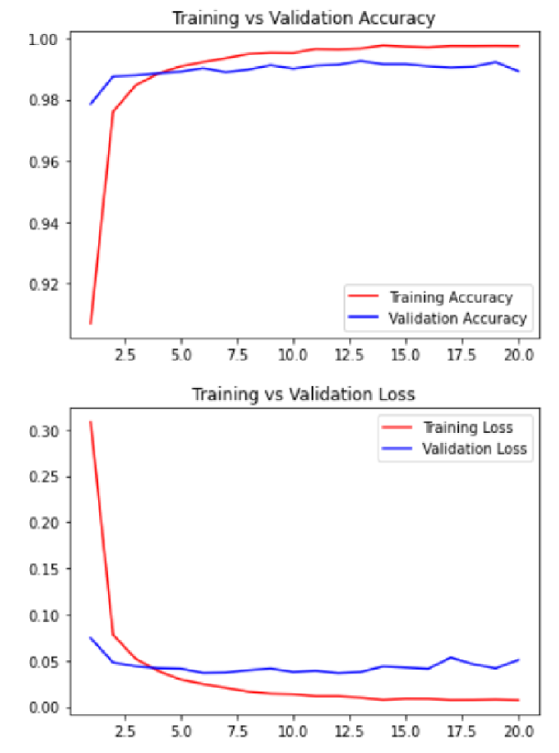

Confusion matrix

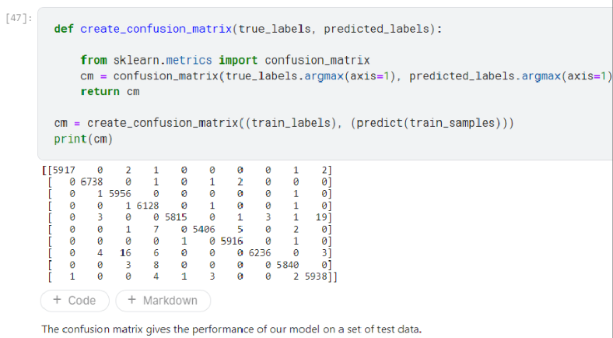

Classification report

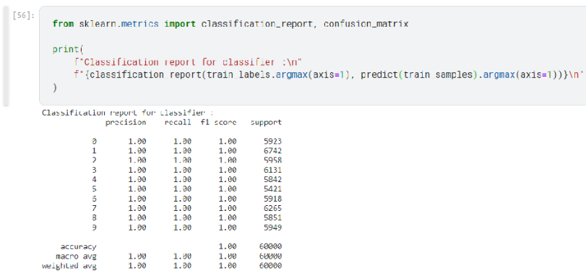

1. **ADVANTAGES & DISADVANTAGES**

* **Advantages** of handwritten digit recognition is that we can reduce our work load at certain places at works like a postman can use OCR to pincode in a letter and sort them accordingly, a teacher can use OCR to type students marks in a excel sheet, a bank employee can use OCR to store the challan number in digital storage.
* Extensive noise removal and smoothing is performed before feeding the image to the model, hence the application performs well even on noisy data.
* Since data augmentation is performed on the available dataset, the application performs well on a diverse range of input data making the model more robust.
* Along with the predicted digits, bounding boxes are displayed around the individual digits as an image to the user.
* **Disadvantages** of Handwritten digit recognition is that each person has different handwritten so it becomes difficult for the model classify images correctly hence it becomes necessary that we have to supply more data to the model.
* The application does not perform well on sequences containing partially/fully overlapping digits.
* Since the model has been trained on a standard dataset with images of a fixed shape, the application’s performance might be affected when rescaling the image to the same fixed shape.
* It requires much more computation than more standard OCR techniques.
* It is not done in real time as a person writes and therefore not appropriate for immediate text input

1. **CONCLUSION**

There are numerous uses for handwritten digit recognition in the fields of medicine, banking, student administration, taxation, etc. To extract the digit from the handwritten image, a variety of classifiers including KNN, SVM, and CNN are employed. According to the evaluation, CNN performs better than the competition. This study discusses the stages of HDR using a CNN classifier. The MNIST dataset is a common dataset used to evaluate the performance of classifiers. It consists of handwritten numbers from 0 to 9. Three separate stages make up HDR. The first step is preprocessing, which involves converting the dataset into binary format and applying image processing on it. Segmentation, the second stage, involves dividing the image into several pieces. The third stage is feature extraction, during which image features are found. CNN is utilised in the classification stage, which comes last. The CNN classifier greatly enhances the outcomes of HDR, but it is still possible to further enhance the complexity, execution time, and accuracy of the results by combining classifiers or utilising other algorithms in addition to CNN.

1. **FUTURE SCOPE**

The task of handwritten digit recognition, using a classifier, has great importance and use such as – online handwriting recognition on computer tablets, recognize zip codes on mail for postal mail sorting, processing bank check amounts, numeric entries in forms filled up by hand (for example ‐ tax forms) and so on.

There is still much work to be done on this project, and it may use a lot of improvement. The following are a few ways this project could be improved:

● Add the ability to save the results of multiple image detection from digits.

● Adding capability to recognise multiple digits

● To detect numbers from complicated images, improve the model.

● Adding support for additional languages will benefit users worldwide. This undertaking has limitless potential and may constantly be improved. By putting this idea into practise in the real world, numerous sectors will gain, many workers' workloads will be reduced, and overall work efficiency will increase

1. **APPENDIX**

Source Code

**1.app.py**

import numpy as np

import os

from PIL import Image

from flask import Flask, request, render_template, url_for

from werkzeug.utils import secure_filename, redirect

from keras.models import load_model

from keras.preprocessing import image

from flask import send_from_directory

from keras.utils import img_to_array

import cv2

UPLOAD_FOLDER = 'C:/Users/DELL/Downloads/'

app=Flask(__name__)

app.config['UPLOAD_FOLDER'] = UPLOAD_FOLDER

model=load_model("assets/mnistCNN.h5")

@app.route("/")

def homepage():

    return render_template("index.html")

@app.route('/predict', methods=['GET', 'POST'])

def upload():

    if request.method == "POST":

        f = request.files["image"]

        filepath = secure_filename(f.filename)

        f.save(os.path.join(app.config['UPLOAD_FOLDER'], filepath))

        upload_img = os.path.join(UPLOAD_FOLDER, filepath)

        img = Image.open(upload_img).convert("L")  # convert image to monochrome

        img=np.asarray(img)

        img=cv2.resize(img,(28,28),interpolation=cv2.INTER_LINEAR)

        thresh,bw_image=cv2.threshold(img,127,255,cv2.THRESH_BINARY)   #converting grayscale to binary image

        bw_image=255-bw_image

        bw_image=img_to_array(bw_image)

        bw_image=np.asarray(bw_image)

        bw_image=np.expand_dims(bw_image,0)

        pred = model.predict(bw_image)

        num = np.argmax(pred, axis=1)  # printing our Labels

        return render_template('predict.html', num=str(num[0]))

if __name__=="__main__":

    app.run()

**2.index.html**

<html>

<head>

  <title>Handwritten Digit Recognition</title>

  <meta name="viewport" content="width=device-width">

  <link href="https://fonts.googleapis.com/css2?family=Prompt:wght@600&display=swap" rel="stylesheet">

  <link href="https://fonts.googleapis.com/css2?family=Varela+Round&display=swap" rel="stylesheet">

  <link href="https://fonts.googleapis.com/css2?family=Source+Code+Pro:wght@500&display=swap" rel="stylesheet">

  <link href="https://fonts.googleapis.com/css?family=Calistoga|Josefin+Sans:400,700|Pacifico&display=swap" rel="stylesheet">

  <link rel="stylesheet" href="https://stackpath.bootstrapcdn.com/bootstrap/4.3.1/css/bootstrap.min.css" integrity="sha384-ggOyR0iXCbMQv3Xipma34MD+dH/1fQ784/j6cY/iJTQUOhcWr7x9JvoRxT2MZw1T" crossorigin="anonymous">

  <link rel="stylesheet" type= "text/css" href= "{{ url_for('static',filename='css/style.css') }}">

  <script src="https://kit.fontawesome.com/b3aed9cb07.js" crossorigin="anonymous"></script>

  <script src="https://code.jquery.com/jquery-3.3.1.slim.min.js" integrity="sha384-q8i/X+965DzO0rT7abK41JStQIAqVgRVzpbzo5smXKp4YfRvH+8abtTE1Pi6jizo" crossorigin="anonymous"></script>

  <script src="https://cdnjs.cloudflare.com/ajax/libs/popper.js/1.14.7/umd/popper.min.js" integrity="sha384-UO2eT0CpHqdSJQ6hJty5KVphtPhzWj9WO1clHTMGa3JDZwrnQq4sF86dIHNDz0W1" crossorigin="anonymous"></script>

  <script src="https://stackpath.bootstrapcdn.com/bootstrap/4.3.1/js/bootstrap.min.js" integrity="sha384-JjSmVgyd0p3pXB1rRibZUAYoIIy6OrQ6VrjIEaFf/nJGzIxFDsf4x0xIM+B07jRM" crossorigin="anonymous"></script>

  <script src="https://cdn.jsdelivr.net/npm/@tensorflow/tfjs@latest"></script>

  <link rel="stylesheet" href="https://cdn.jsdelivr.net/npm/bootstrap@4.6.1/dist/css/bootstrap.min.css">

  <script src="https://cdn.jsdelivr.net/npm/jquery@3.6.0/dist/jquery.slim.min.js"></script>

  <script src="https://cdn.jsdelivr.net/npm/popper.js@1.16.1/dist/umd/popper.min.js"></script>

  <script src="https://cdn.jsdelivr.net/npm/bootstrap@4.6.1/dist/js/bootstrap.bundle.min.js"></script>

</head>

<style>

    body{

     /*background-image: url("static/images/Background_Image.jpg");*/

     background-repeat: no-repeat;

     background-size: cover;

    }

</style>

<script>

  function preview() {

    frame.src=URL.createObjectURL(event.target.files[0]);

}

    $(document).ready(function() {

          $('#clear_button').on('click', function() {

              $('#image').val('');

              $('#frame').attr('src',"");

            });

        });

</script>

<body>

        <div class="container p-3 my-3 bg-dark text-white">

            <p style = "text-align:center;font-family:Prompt" > A Novel Method for Handwritten Digit Recognition System</p>

      <p style = "text-align:center;font-family:Prompt"> Team ID - PNT2022TMID35610</P>

        </div>

        <section id="content">

            <div class="leftside">

            <form action="/predict" method="POST" enctype="multipart/form-data">

            <label>Select a image:</label>

            <input id="image" type="file" name="image" accept="image/png, image/jpeg" onchange="preview()"><br><br>

              <img id="frame" width="100px" height="100px"/>

              <div class="buttons_div">

                <button type="submit" class="btn btn-danger" id="Predict_button">Predict</button>

                <button type="button" class="btn btn-danger" id="clear_button">&nbsp Clear &nbsp</button>

              </div>

            </form>

            </div>

      </section>

</body>

</html>

**3.predict.html**

<!DOCTYPE html>

<html lang="en">

<head>

    <meta charset="UTF-8">

    <title>Prediction</title>

</head>

<style>

    body{

     /*background-image: url('static/images/Background_Image.jpg');*/

     background-repeat: no-repeat;

     background-size: cover;

    }

    #rectangle{

     width:400px;

     height:150px;

     background-color: #000000;

     border-radius: 15px;

     position:absolute;

     box-shadow: 0px 0px 10px 5px white;

     top:25%;

     left:50%;

     transform:translate(-50%,-50%);

    }

    #head{

  text-align: center;

  font-size: 30px;

  margin: 0 auto;

  padding: 3% 5%;

  font-family: Arial, Helvetica, sans-serif;

  color: white;

    }

    #num{

        font-size: 50px;

    }

</style>

<body>

    <div id="rectangle">

        <h1 id="head">Predicted Number : <br><center id="num">{{num}}</center></h1>

    </div>

</body>

</html>

GitHub & Project Demo Link

GITHUB LINK🡪 <https://github.com/IBM-EPBL/IBM-Project-4372-1658730006>